**Lab – 6**

**Identification, Simulation and Control of a flexible structure**

Question 1: Method 1 - Frequential analysis

The resonance frequency corresponds to the point where we have maximum gain. We first have Bode diagrams between 20Hz and 30Hz with 0.5 Hz step.

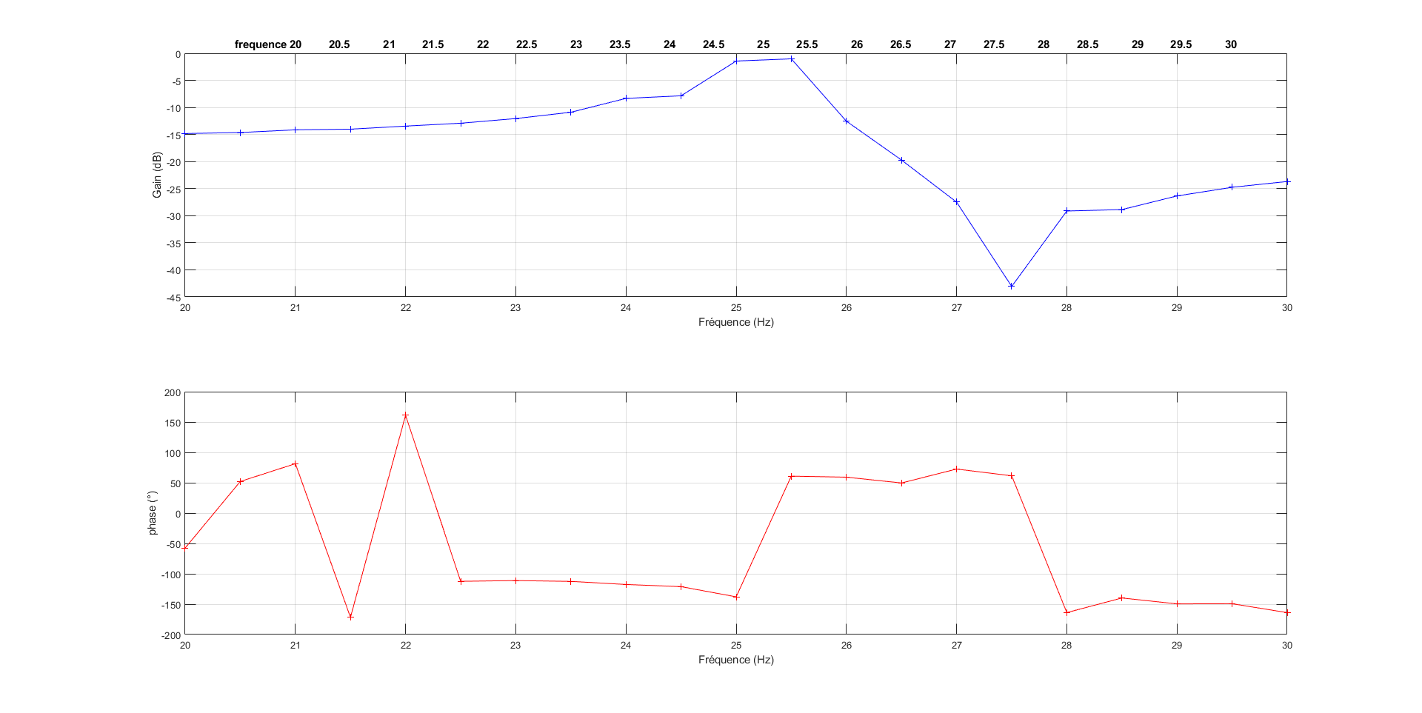

After this, the experiment was redone to accurately capture the exact frequency. The bode diagrams plotted are between 24.8Hz and 25.8Hz with a step size of 0.05Hz, since the Gmax is observed somewhere in this range.

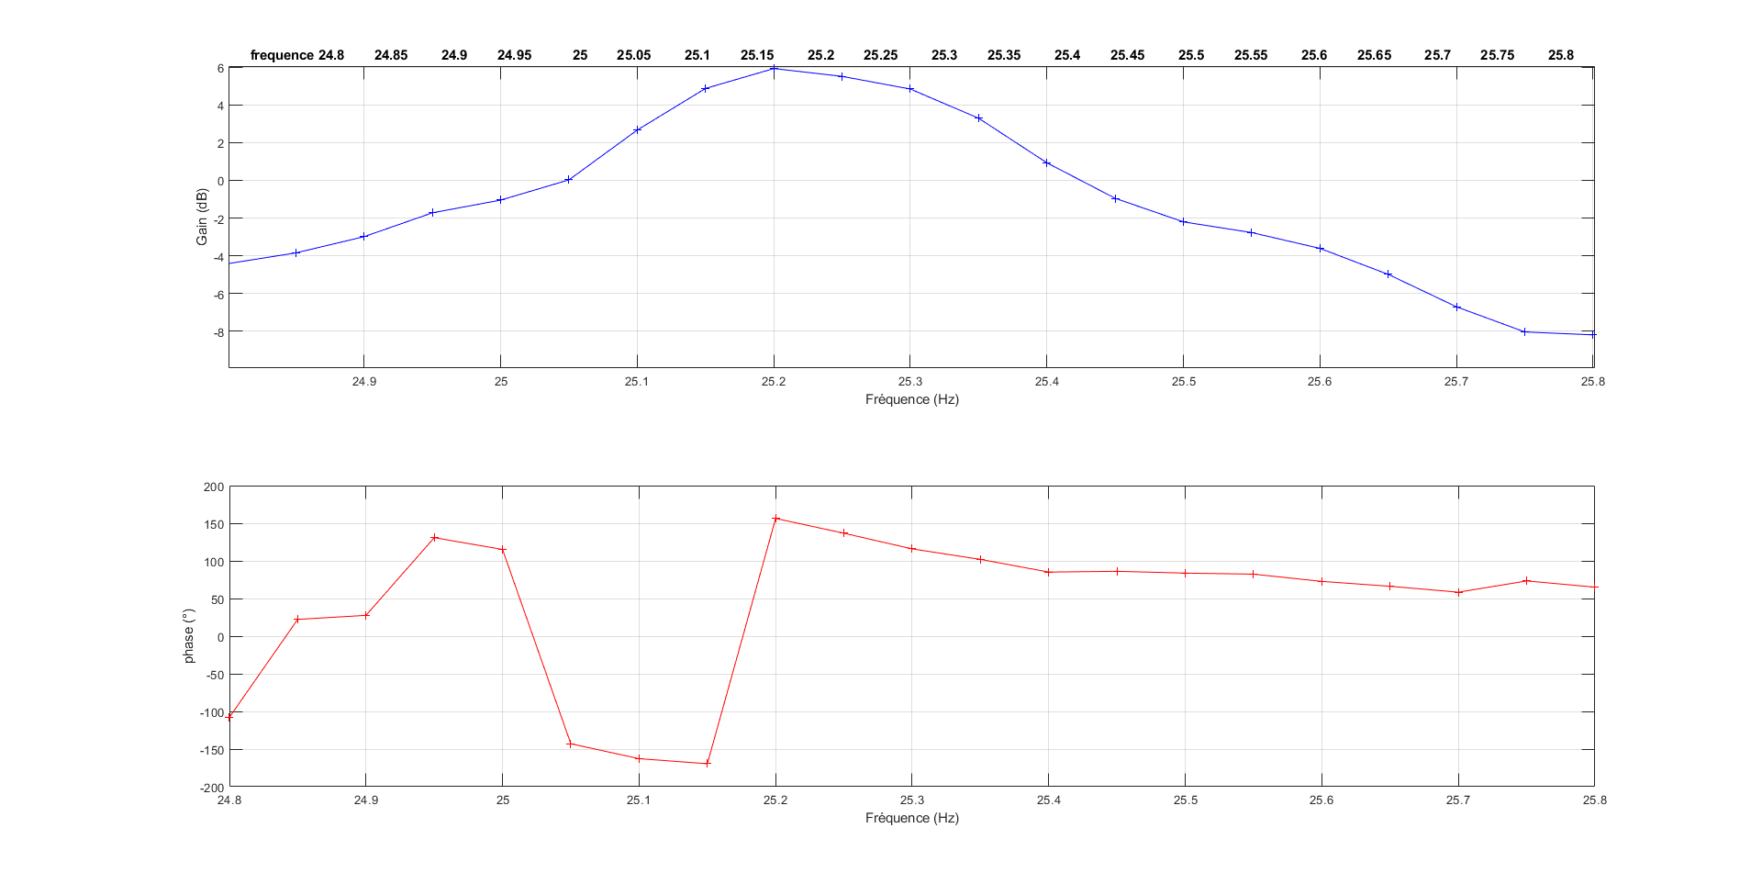

The resonant frequency is observed to be at 25.2 Hz. The corresponding Gmax is 5.919dB. From the figures, the frequencies, ω1 and ω2 are recorded at (Gmax-3)db and the final damping factor is calculated.

Gmax = 5.919dB

ω0 = 25.2Hz

ω1 = 25.1058Hz ω2 = 25.3577Hz

Therefore, Quality factor Q is

Q = 100.039

**ɛ = 0.0049**

Question 2: Method 2 - Temporal analysis

We have the time response of the beam in response to initial excitation.

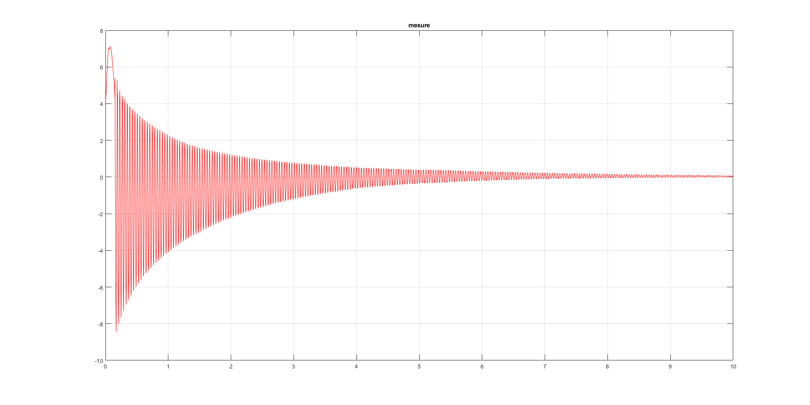

Three different pairs of consecutive overshoot values were taken at random and the corresponding damping ratios were calculated.

ɛ1 = 0.00459

ɛ2 = 0.00503

ɛ3 = 0.00418

The overall damping factor is calculated as the average of these values.

**ɛ = 0.0046**

The time period is calculated by measuring the time taken for one cycle of vibration which is as follows.

T = 0.0384s

Therefore,

**ω = 26Hz**

Question 3: analyze the previous results.

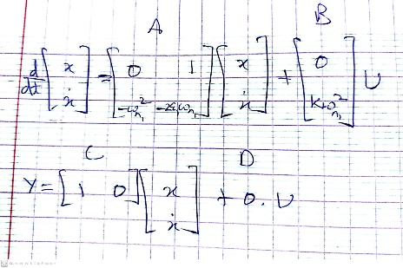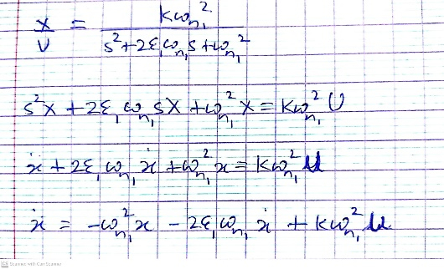To get the time response of the flexible beam, matrices A,B,C,D are calculated manually as shown. The stop time was set to 10s to capture the graph properly.

The final time response obtained shows a similar behavior to the measured time response from the experiment. Any differences can be attributed to the fact that the experiment was conducted with an arbitrary initial displacement and other factors such as gravity and air resistance can cause the experimental plot to differ from the simulation counterpart.

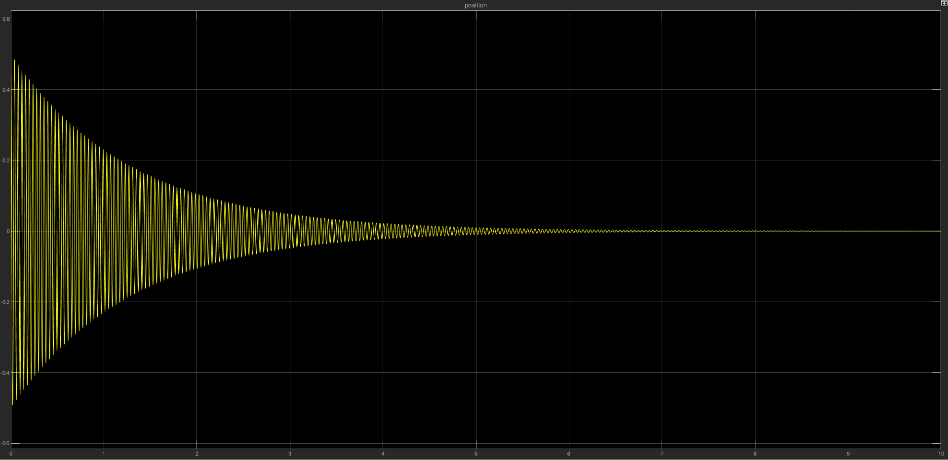

Case 1: Model with one mode

A feedback is introduced on the velocity gain given by the relation

u = -KaKcKs v

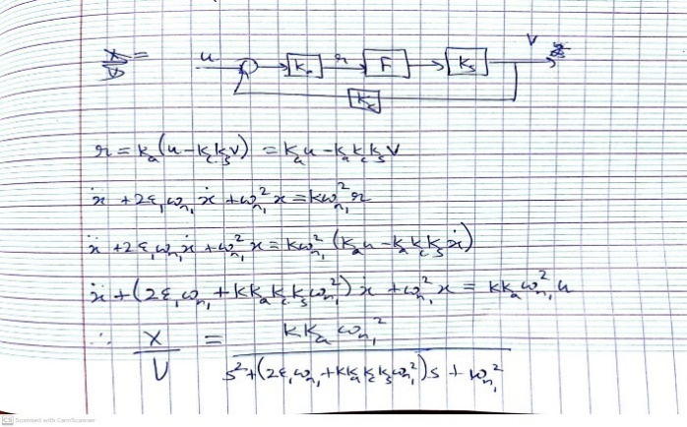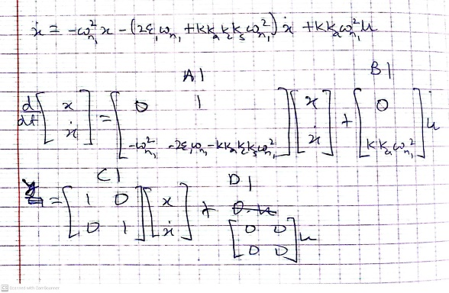The state vector is [x xdot]T and in this case, since we send velocity gain back to the input through feedback, we must include it in the output vector along with displacement. Therefore, the values of A1,B1,C1,D1 must be adjusted as follows. The feedback gain Kc1 is calculated for the critical damping case through the relation derived below.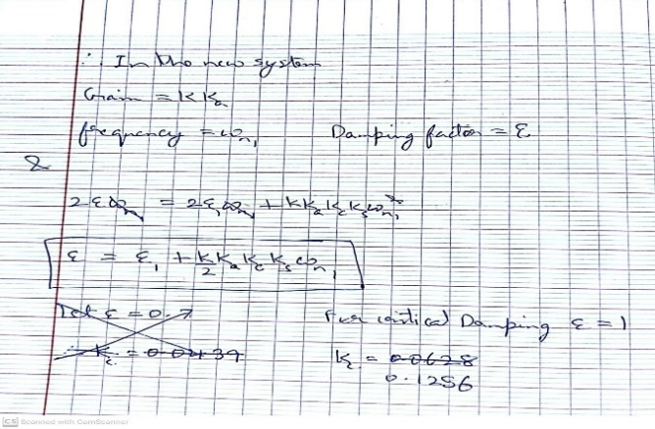

**Kc1 = 0.1256** is the optimal value at which the system is found to be critically damped. In this figure, the stop time is set to 1s to capture the curve.

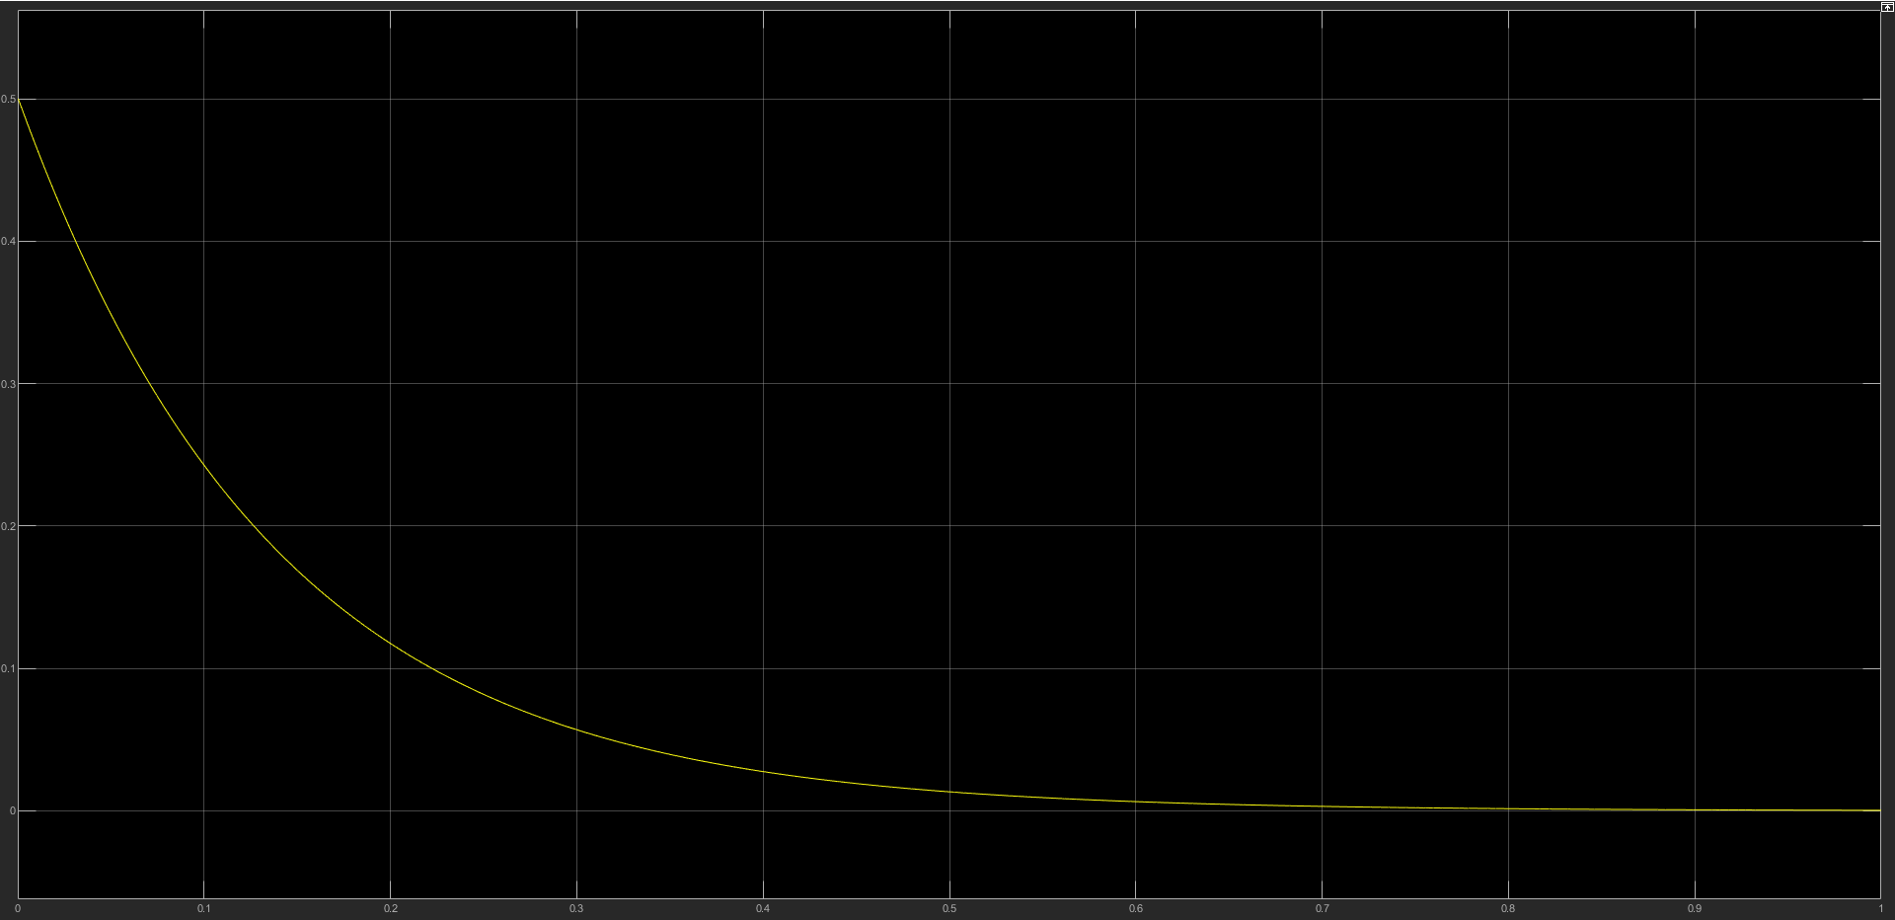

Case 2: Model with two modes

A model with 2 modes is a 4th order control system which consists of 2 2nd order systems. The additional polynomial F2 is added for the 2nd mode and the matrices A2,B2,C2,D2 are calculated manually in the same way as before.

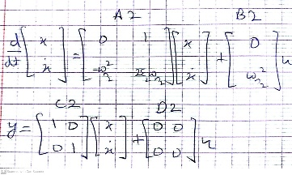

In this case, **Kc2 = 0.015** is proposed to control damping. In the figure below, we see the time response for the cases of open loop vs closed loop with 2 modes. There is significant improvement in the response as the beam comes back to rest much earlier at about 0.55s compared to the open loop model which finally comes to rest at about 7s.

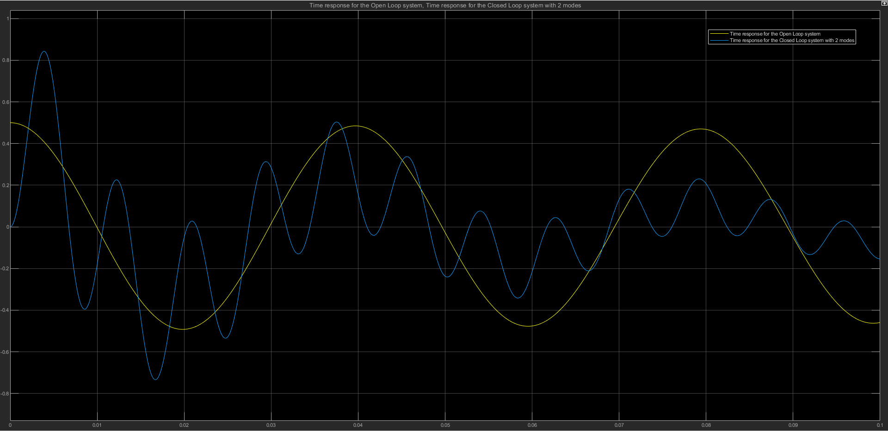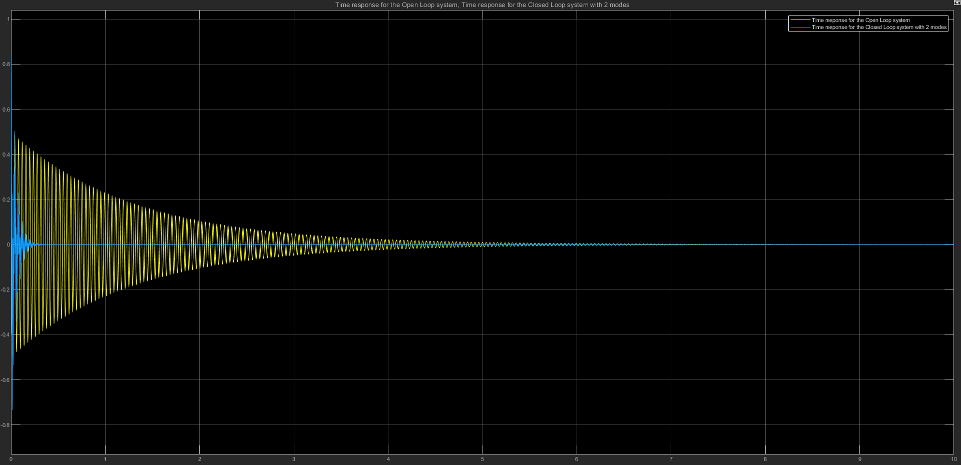

Analysis:

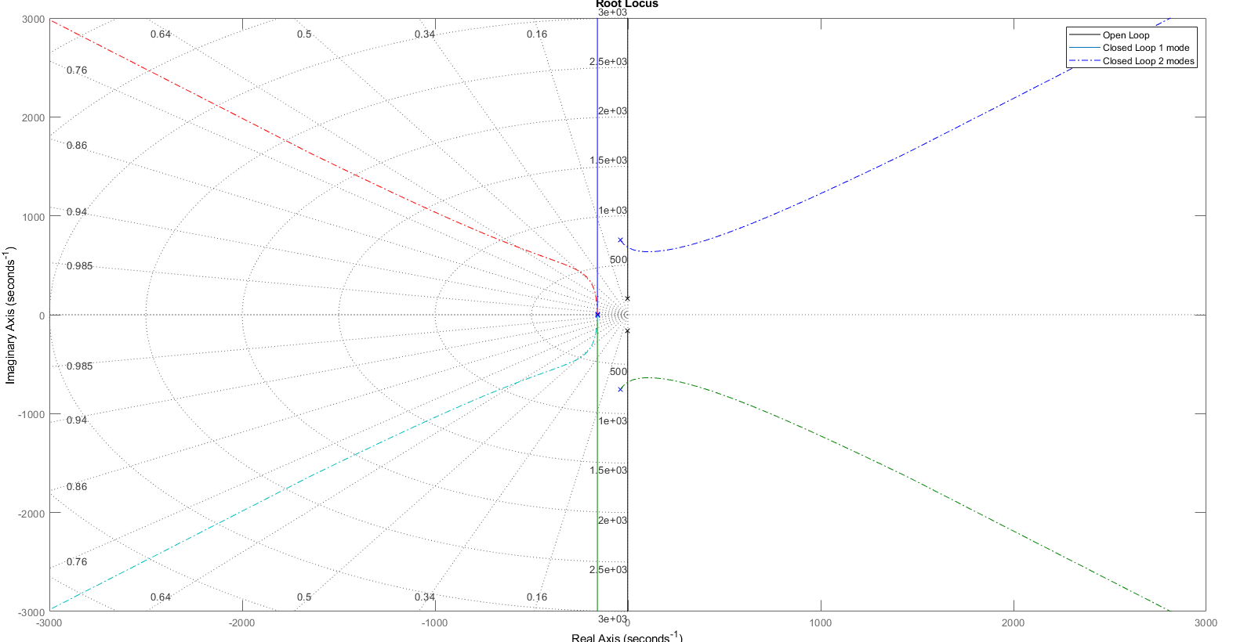

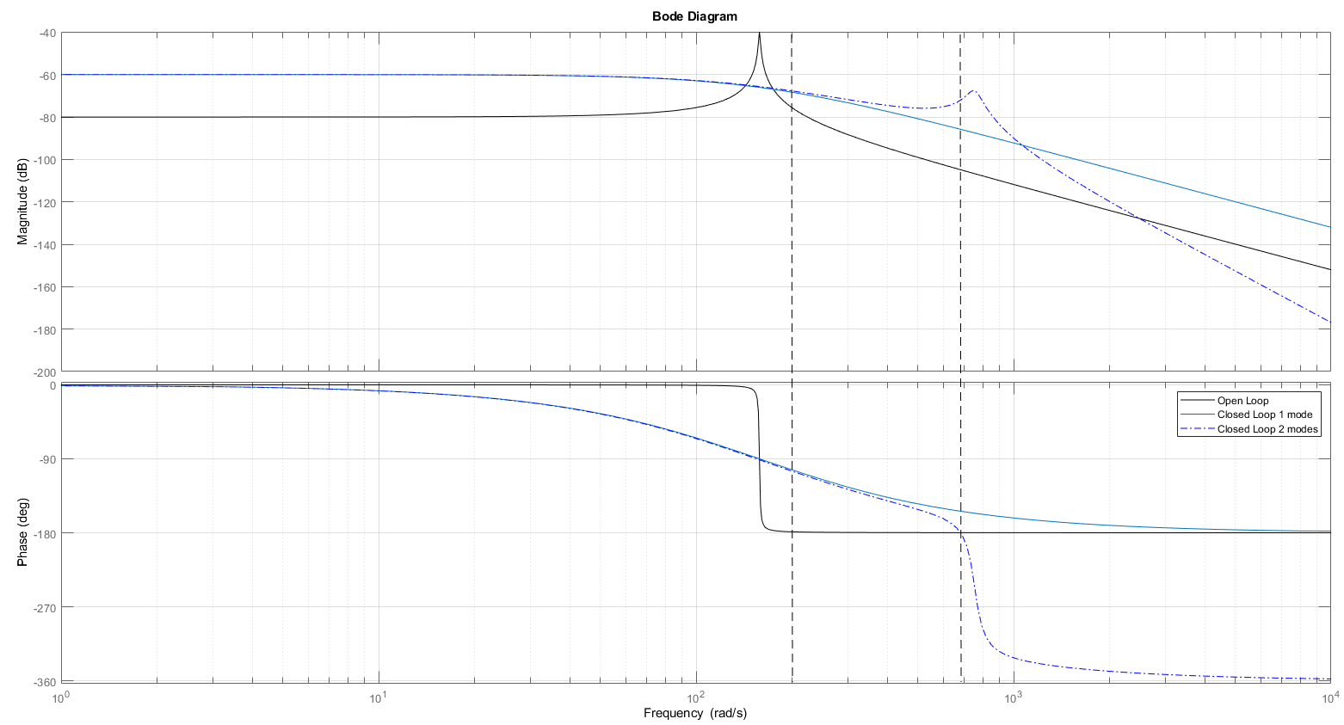

1. The Closed loop controller in mode 1 provides the greatest stability as the roots, as seen in the rlocus plot, in that model are negative and real. The mode 2 controller has 2 additional roots that are very close to the positive instability region.
2. The mode 1 controller also has the highest gain margin at about 132 dB.